HOW TO INSTALL AND CONFIGURE

***EclipseMARS -JavaFX***

(July 2016)

****************************************************

**JavaFX – Installation**

**STEP 1:**

Open **EclipseMARS**.

**STEP 2:**

**Go to :** <https://o7planning.org/en/10619/install-efxclipse-into-eclipse#a2721136>

**This site should be enough for everything!**

**IGNORE what is below!**

Go to **Help 🡪 Install new software 🡪Add**.

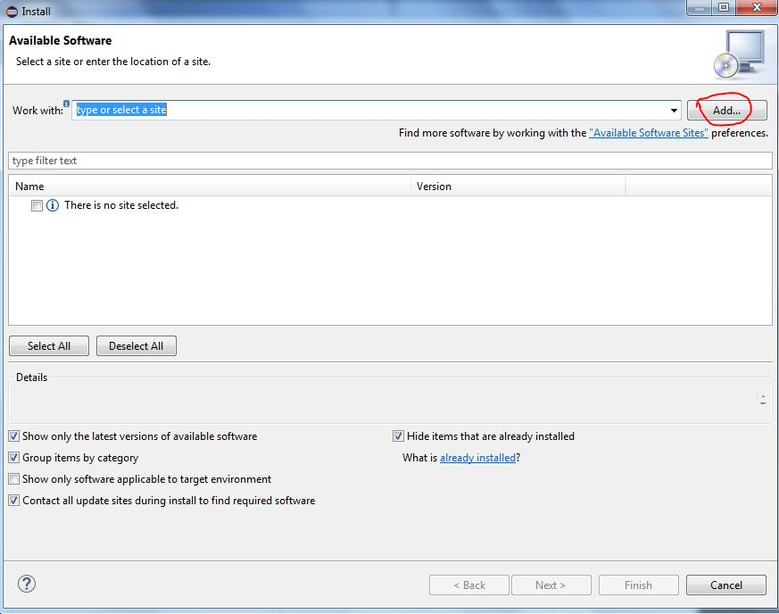

**STEP 3:**

Type the following details in the Add Repository area.

Name: **e(fx)clipse**

Location**: http://download.eclipse.org/efxclipse/updates-released/2.1.0/site**

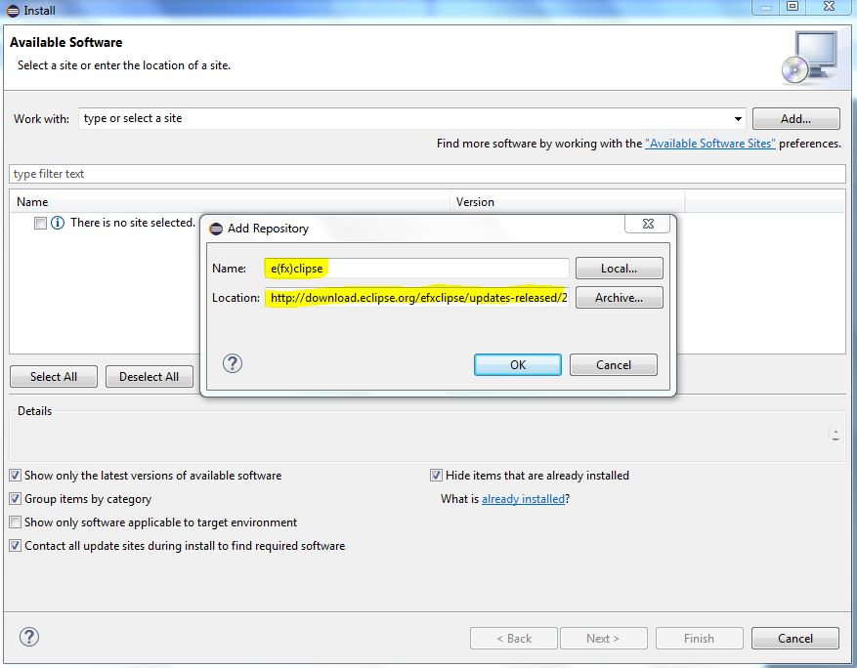

**STEP 4:**

Check the components and click next to finish the installation.

